Nama : Hafizh Rafi Muhammad

Nim : 181402069

Kom : C

**TUGAS 2 DATA WAREHOUSE & BUSINESS INTELIGENCE**

**2. Create the Pivot Table**

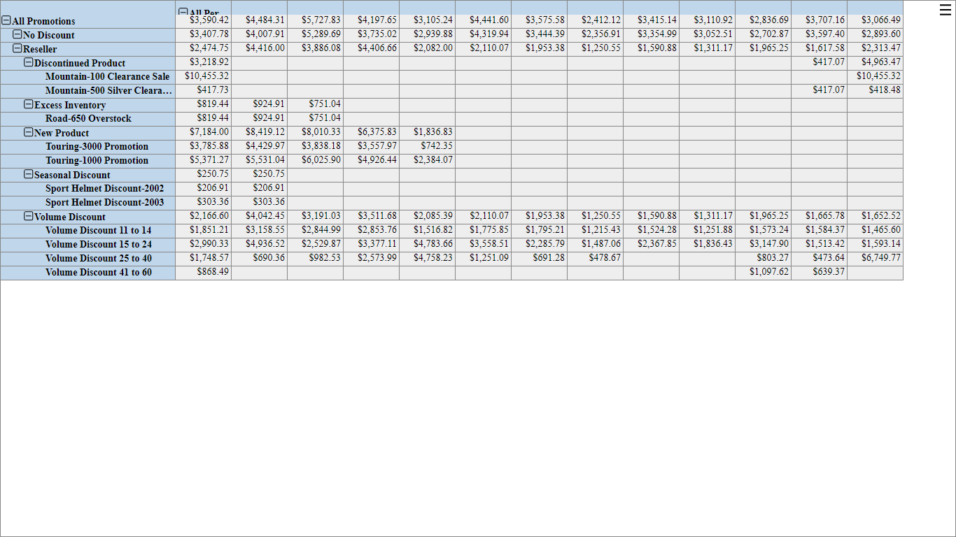

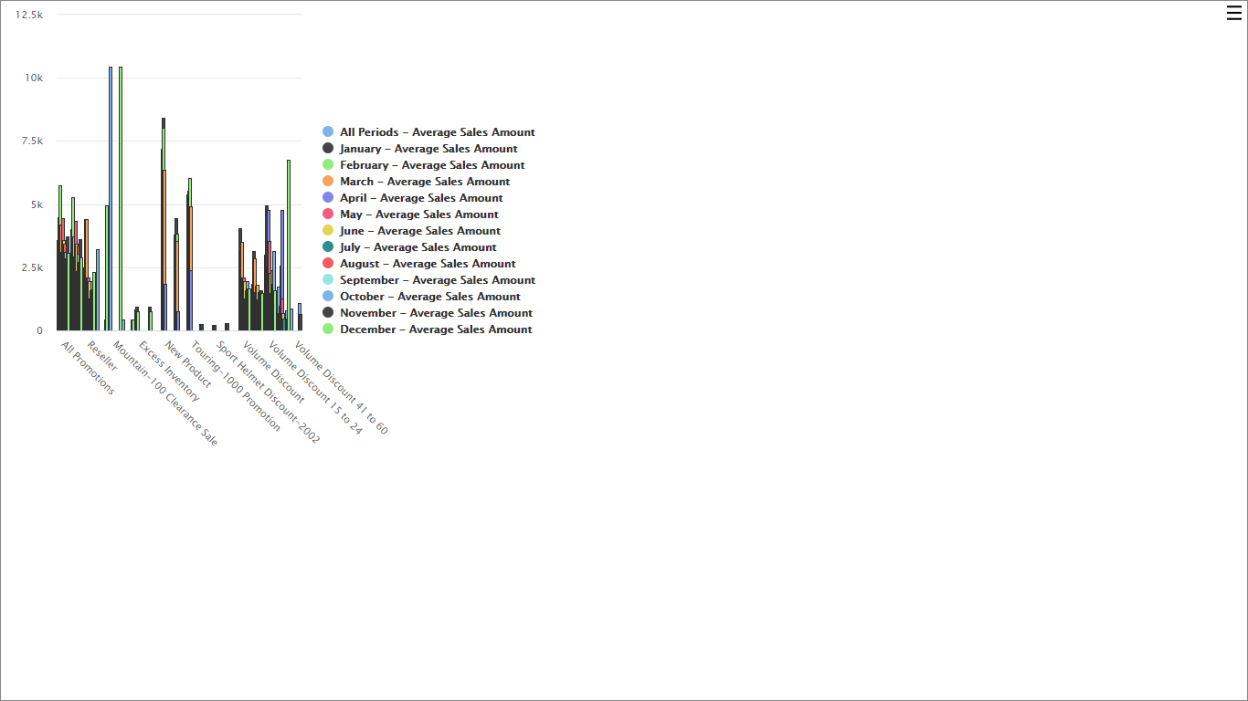

**3. Extend the Pivot Table**

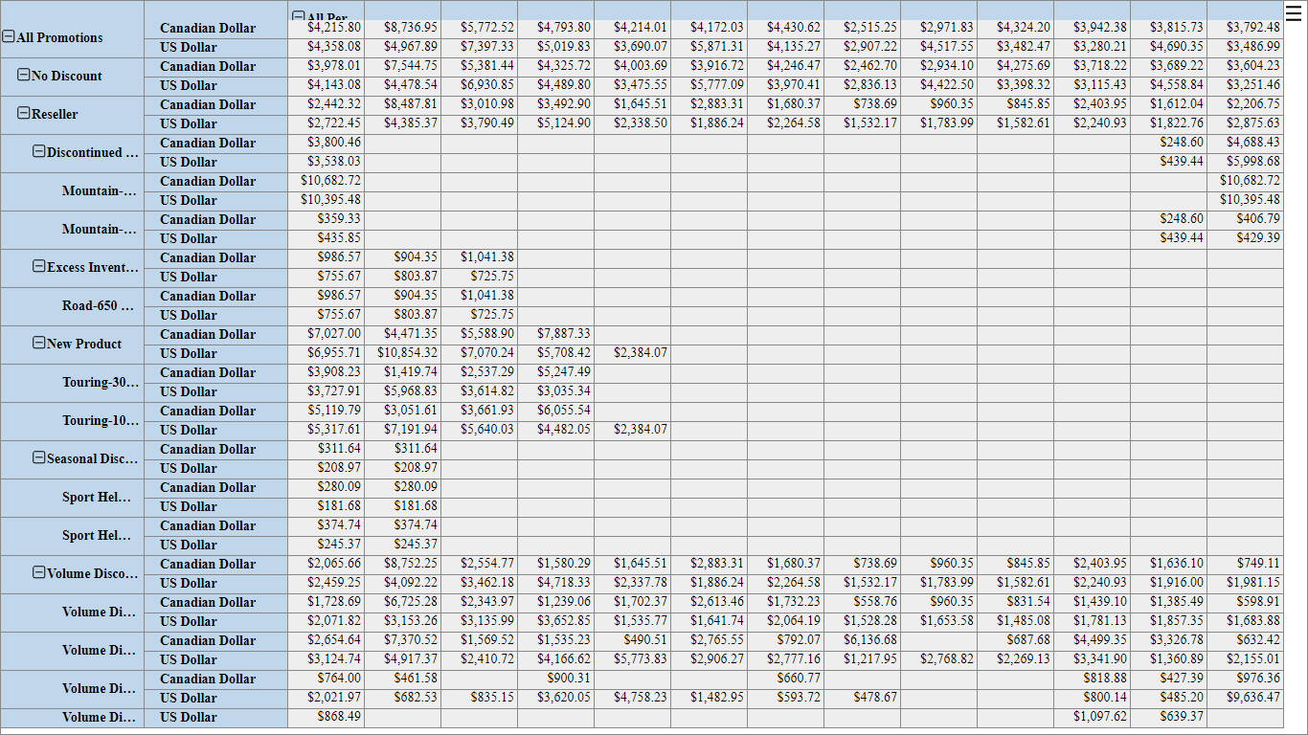

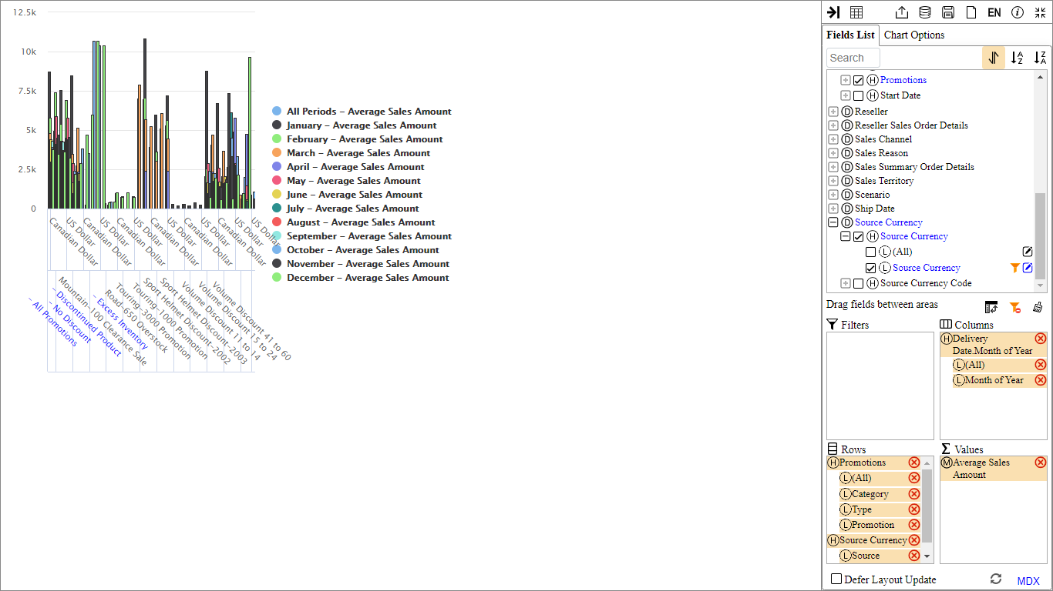

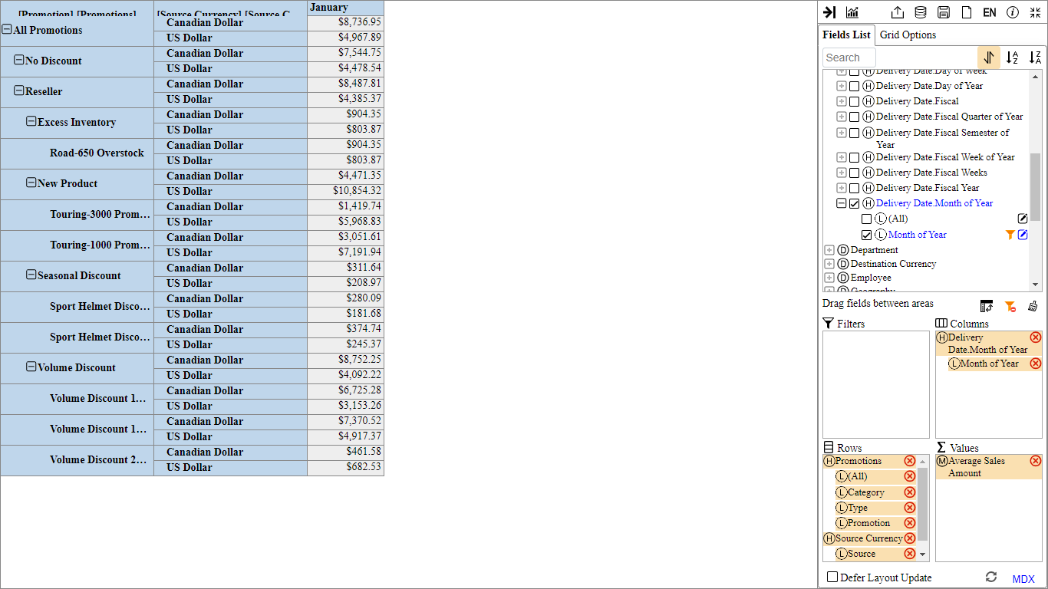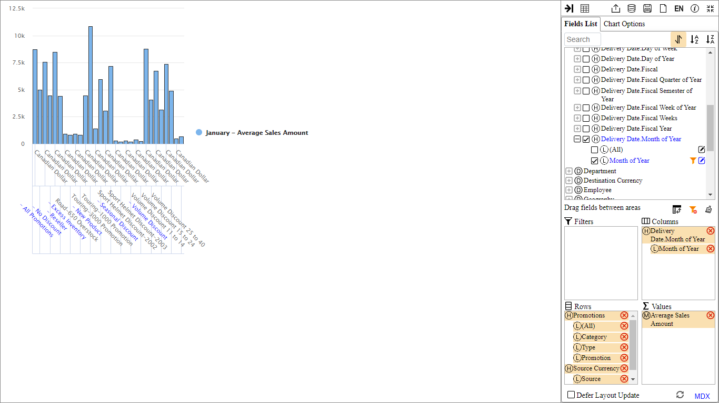

**4. Extend the Pivot Table with Filter Changes and Rollups**

